Theory of Automata (CS3005)
Date: May 20th 2025
Course Instructor(s)
Dr. Nasir-uddin, Ms. Shaharbano, Ms. Bakhtawar, Ms. Abeeha Sattar, Syed Faisal Ali
Final Exam
Total Time (Hrs): | 3
Total Marks: | 50
Total Questions: | 4

___________ __________ _____________________

Roll No Section Student Signature
Do not write below this line
- Attempt all the questions.
- Make clear diagrams with proper notations.
- Read all the instructions on Answer Sheet, Fill the credentials properly.
- Do not waste pages. Start from page number 2.
- Assume and state your assumption clearly if you feel question is having ambiguity.
- Understanding of the paper is the part of exam, do not call faculty members.

CLO 2: Prove properties of languages and automata with rigorously formal mathematical methods
Question 1: Short Answer questions: [4 Marks][15 Mins]

- Why is the subset construction method used in converting an ε-NFA to a DFA?
- How does the transition function differ in an NFA compared to a DFA?
- Provide a regular expression for Pakistani CNIC.
- What is the language of a DFA having no accepting state? What will be the Kleene star of this language?
- Differentiate between regular and context-free grammars.
- What are the components of a formal grammar?
- What is the significance of Kleene's Theorem in automata theory?
- Every linear grammar cannot be accepted by DFA, debate in two lines.

CLO 3: Design of automata, RE and CFG
Question 2 [2+1+2+2+5 Marks] [30 mins]
- Find the DFA using ε-closure  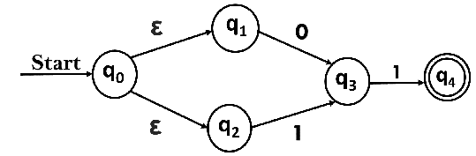 | - Give the inverse of your DFA.  - Produce the Grammar for the given RE.  [(0+1)∗ 0 (0+1)∗ 1 (0+1)∗] + [(0+1)∗ 1 (0+1)∗ 0 (0+1)∗]
- Produce Grammar of given DFA.  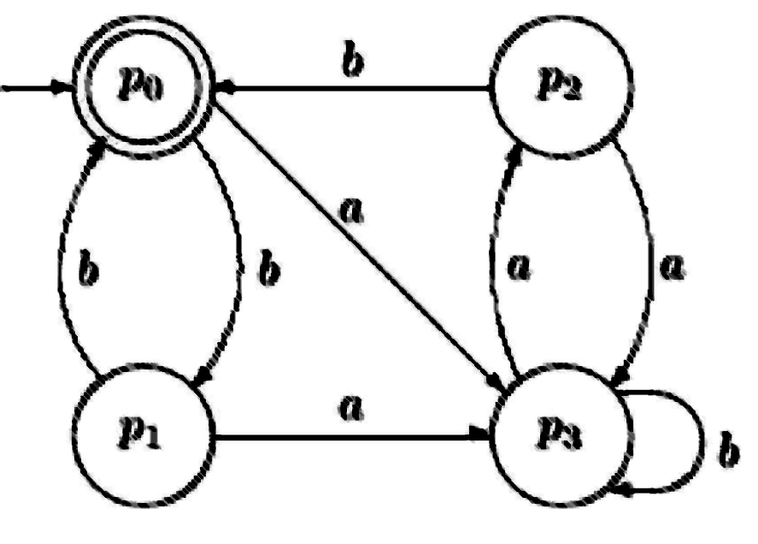 | - Simplify and clean the following grammar in proper order and then find the CNF:  S → ABCD| AB|CED|FD  A → abd | bdc| EF  B → xyz | wxy |xE | yF  C → xA | yB | wF  E → a | b | c

CLO 5: Define Turing machines, PDA machines performing simple tasks.
Question 3 . [3+3+5+5 Marks] [60 mins]

Design PDA and CFG of given language.
- Language of all strings over the alphabet {0, 1, 2} that never starts and ends with the same symbol. | - All strings w such that |w_{a}| = 3 mod 4 upon the alphabet set {a,b}.  e.g. bbbbbabaab, baaabaaaab………
- L(G) ={0^{n} 1^{m}| n!=m} | - L={ 0^{n} 1^{m} |3^{n} <= m <= 4^{n}}  e.g. 0111,01111,0011111111

CLO 5: Define Turing machines, PDA machines performing simple tasks.
Question 4. [4+4+10 Marks] [60 mins]

Design TM for the following descriptions:
- The set of all strings of length 5, defined over Σ = {0,1} contains at least two 0’s or at most three 1’s:
Some accepted strings: 00000, 00001, 00111, 10101
Some rejected string: 11110, 11111
- Accept the language L = {b^{m} a^{n} a^{m} b^{n} | m>=2n>=0}

- The TM processes two unary numbers A and B:

  - If input A is greater than the input B then the output is A+B.
  - If input A is less than the input B then the output is B - A.
  - If input A is equal to the input B then the output is 2 x A x B.

*=*=*=*=*=*=*=*=* GOOD LUCK *=*=*=*=*=*=*=*=*

